**Assignment 3 – Machine Learning in Practice (17691)  
Carnegie Mellon University, Spring 2022**(Chirag Huria)

**Task 1**

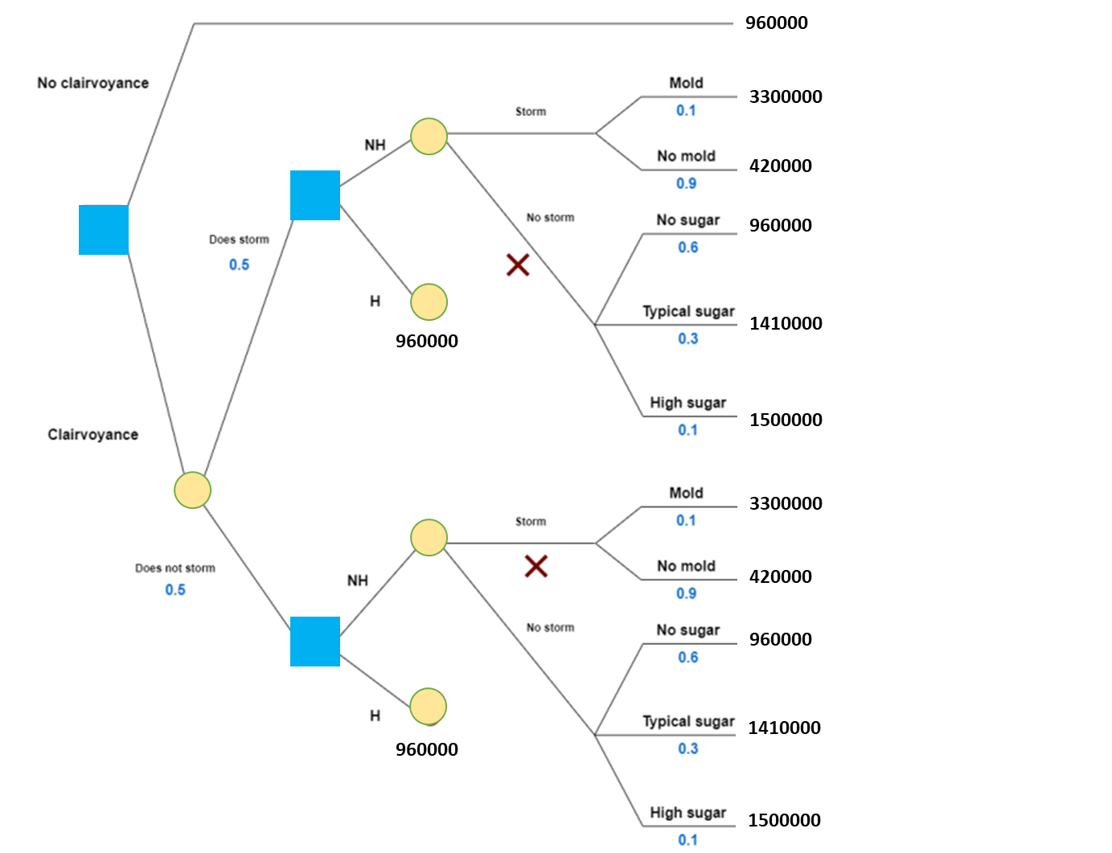

**E-Value** = (0.5 * 960000) + (0.5 * 1149000) = **$1,054,500**

**Value of Clairvoyance** = 1054500 – 960000 = **$94,500**

The recommended course of action would be to **buy the clairvoyance**.

**Task 2**

My model has the following values for True[False] Positive[Negative].

True Positive (TP) = 19

False Positive (FP) = 10

True Negative (TN) = 78

False Negative (FN) = 19

**Calculations**

Sensitivity = TP / (TP + FN) = 0.5

Specificity = TN / (TN + FP) = 0.88

P(DS) = TP+FP/ total = 0.23

P(DNS) = 1 – P(DS) = 0.77

P(S|DS) = TP/ TP + FP = 37/ 49 = 0.65

P(NS|DS) = 1 - P(S|DS) = 0.35

P(S|DNS) = 1 - P(NS|DNS) = 0.19

P(NS|DNS) = TN/ TN + FN = 0.81

**Updated Decision Model**

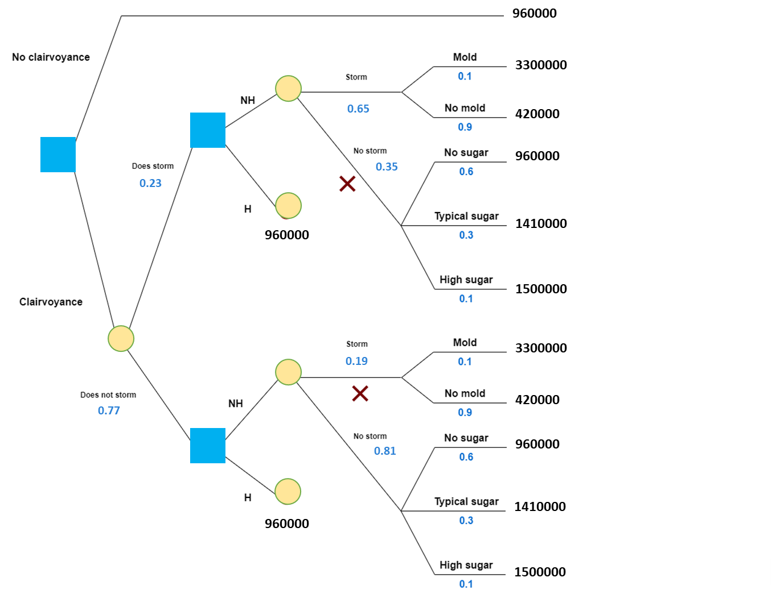

**Value of Data**

Max[960000, FILL THIS] =

The recommended course of action would be to **buy the clairvoyance**.

**Model Quality**

At the following levels of sensitivity=0.48 and specificity=0.76, we will be indifferent to the model development.

**Task 3**

Streamlit Link:

**Task 4**

Folowings